CAMPAIGN INSTRUCTIONS
Optional: “I dedicate my mindful mitzvahs as a zechus for refuah/to honor __________”
1. Say Daily Declaration* on center page every morning
2. Use Kavanah Kard** meanings on center page to focus
on meaning of Hashem’s names with 1 or more brachos
3. Think or say: “I am fulfilling the mitzvah of _____
as Hashem commanded” before one or more mitzvahs. (This is the halacha in Shulchan Aruch)
4. Do teshuva for any lack of proper kavanah with mitzvahs or brachos & mark chart. (Guided process on KavanahKards.com/mindfulmitzvahs or call us.)
5. Spend 5-10 minutes a day thanking Hashem for the things you don’t want to have in your life (based on Say Thank-you And See Miracles, by Rabbi Shalom Arush)
6. Mark your Mindful Mitzvahs on center page log***
7. Optional: Conference call – to get & give help
8. Increase your Mindful Mitzvahs as you are ready
9. Ask Hashem to help you & thank Him for it
10. Optional: get a Campaign partner (we will help)
11. Share with others – great zechus for bringing them closer to Hashem!
12. Let us know how you’re doing so we can celebrate you
13. Grow your Mindful Mitzvahs into a lifelong practice!
Your happy experiences will BE”H encourage others. Please share them.
Donations are very needed and appreciated to help expand the Mindful Mitzvahs Campaign. Seeking people to help bring Mindful Mitzvahs to their community. Thank-you!
BS”D
WANT TO FEEL CLOSER TO HASHEM?
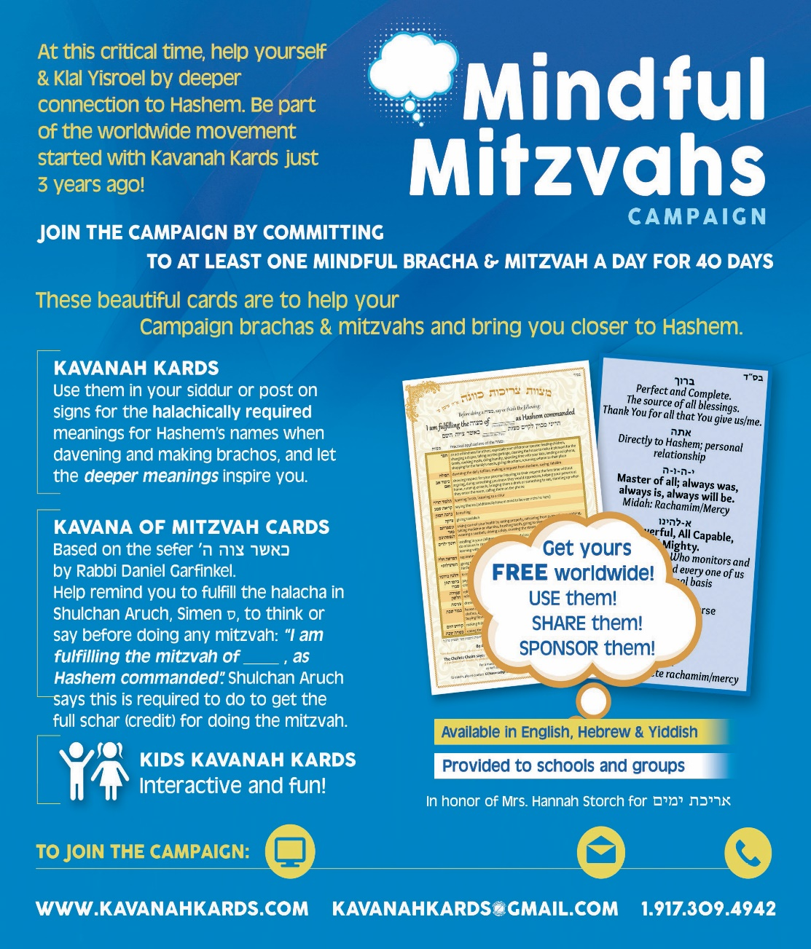
Support recordings for women
http://www.kavanahkards.com/kavanah-calls.html or
call (515) 604-9664, pin 817216 #, recording # 1-13

KAVANAH KARD MEANINGS** – (straight=required, Italics=to inspire)  Baruch: Perfect & Complete The source of all blessing; Thank-You for all you give us  Attah: Directly to HaShem; personal relationship  HaShem: Master of All; always was, always is, always will be. Attribute: Mercy  Elokeinu: all-Powerful, all-Capable, all-Mighty; powerful Master who monitors and oversees each and every one of us on a personal basis  Kayle: Attributes: Love, complete Mercy | DAILY DECLARATION*  (This does not cover Shema or 1st paragraph of Shmoneh Esrei)  I hereby declare my intention that from this moment until tomorrow, every time I mention the name Adnut, blessed be His name, my intention is that He is the Master of all. And every time I mention the name Havaya , blessed be His name, my intention is that He is the Master of all, always was, is and will be. And when I mention the name Elokim, my intention is that He is Mighty, all capable, Master of all powers.
MINDFUL MITZVAHS CAMPAIGN LOG*** BS”D
BRACHOS & MITZVAHS GOAL # PER DAY:_____ DATE STARTED:_______ (OPTIONAL: ZECHUS FOR _________) TESHUVA: _____(#4
NOTE: each day mark the box with what you have done and one for each mindful mitzvah and bracha. Copy blank for others
MITZVAH | NOTES | 1 | 2 | 3 | 4 | 5 | 6 | 7 | 8 | 9 | 10 | 11 | 12 | 13 | 14 | 15 | 16 | 17 | 18 | 19 | 20
Declaration
# Mitzvahs
# Brachos
Ask H’s help
Partnered | If have one
Shared | # people
Thank Hashem | For problems-10’

MITZVAH | NOTES | 21 | 22 | 23 | 24 | 25 | 26 | 27 | 28 | 29 | 30 | 31 | 32 | 33 | 34 | 35 | 36 | 37 | 38 | 39 | 40
Declaration
# Mitzvahs
# Brachos
Ask help | Hashem
Partnered | If have one
Shared | # people
Thank Hashem | For problems-10’

What do you notice improves? (Please let us know)

1. ________________________________
2. ________________________________
3. ________________________________
4. ________________________________

